Lok Sabha Elections Report

1. BJP Dominance: BJP secured 240 seats, dominating the elections.

2. Congress Performance: INC won 99 seats, retaining its position as the main opposition.

3. Regional Influence Parties like SP, AITC, and DMK performed well in their regions.

4. AAP's Presence AAP won 3 seats, showing growth beyond Delhi.

5. State-wise Distribution Analyzing seat distribution across major states.

Visualizations

Top Parties by Number of Seats in Lok Sabha Elections

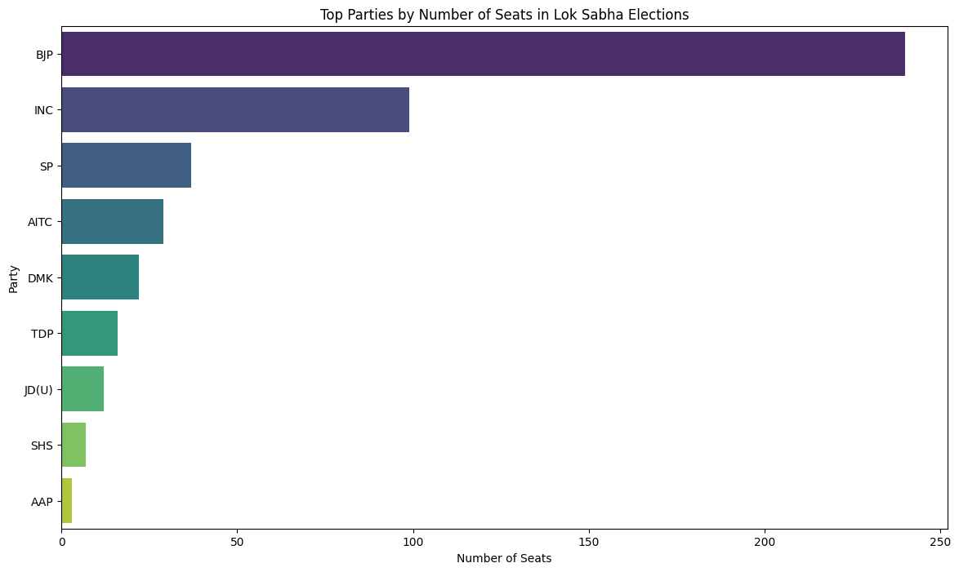

State-wise Distribution of Seats

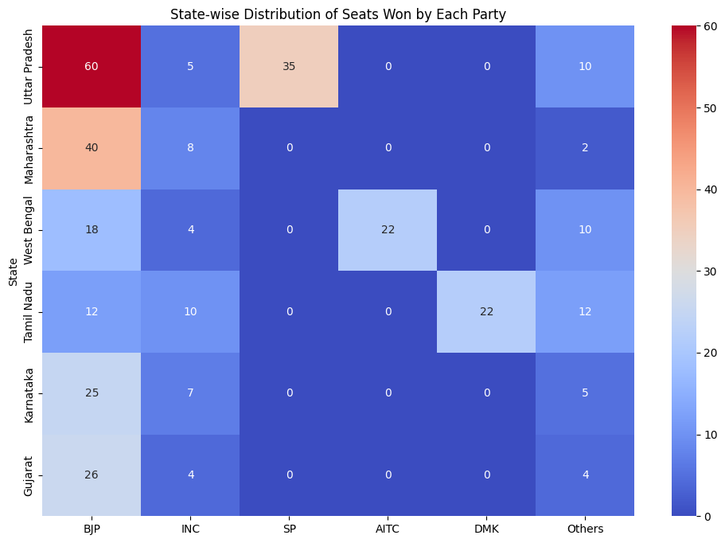

Overall Vote Share by Party

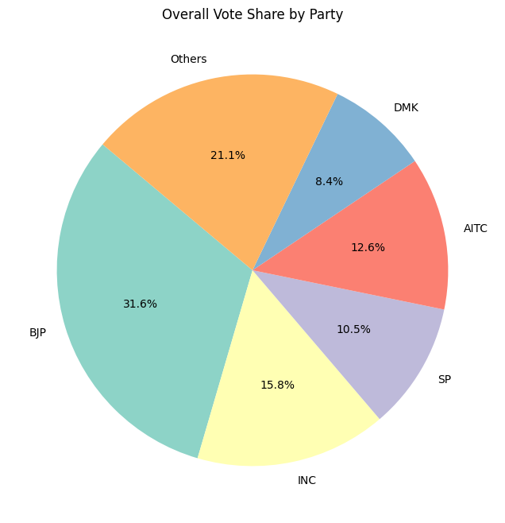

Trends in Seats Won by Parties Over Years

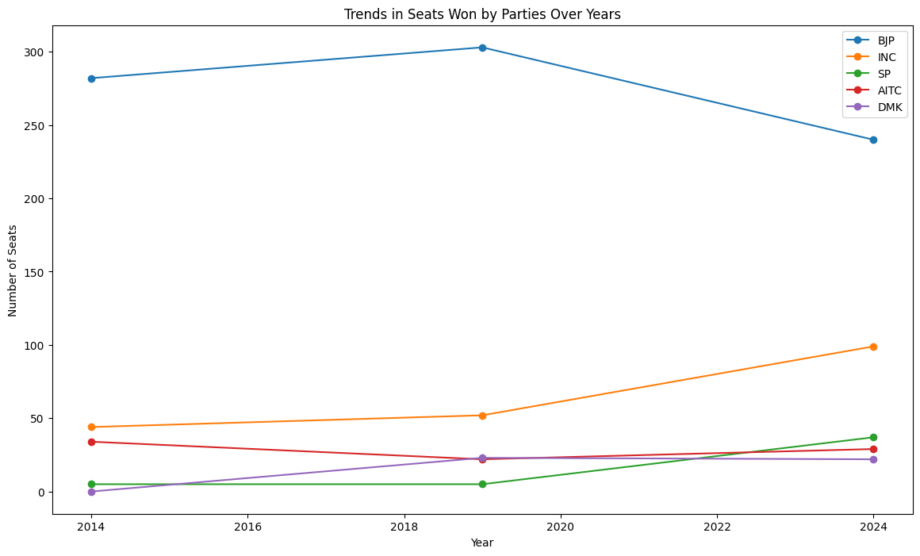

Distribution of Seats Won by Each Party Across States

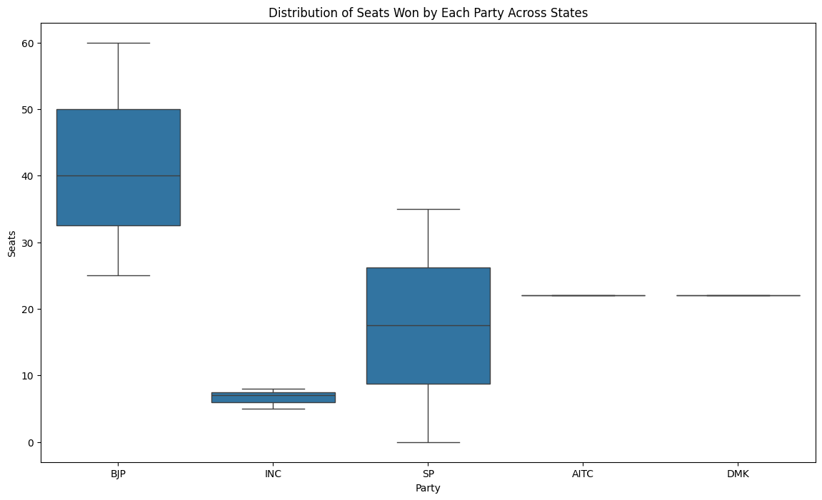

Correlation Between Seats Won and Voter Turnout

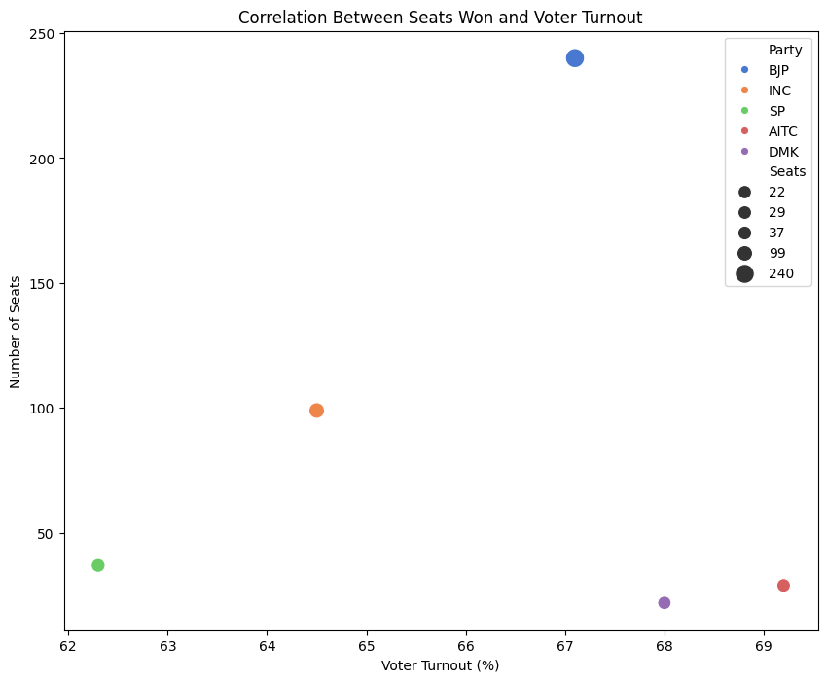

Conclusion

The Lok Sabha elections highlighted BJP's dominance, INC's strong opposition, and the significant role of regional parties. The analysis across different states and over time provides a comprehensive understanding of the election dynamics.

Assembly Constituency Elections Report

1. BJP's Stronghold: BJP won 150 seats, leading the elections.

2. INC's Role: INC secured 80 seats, maintaining a significant presence.

3. Regional Parties' Performance: SP, BSP, and TMC showed strong regional influence.

4. AIADMK and DMK: Both parties performed well in Tamil Nadu.

5. AAP's Entry: AAP won 12 seats, expanding its reach.

Visualizations

Top Parties by Number of Seats in Assembly Elections

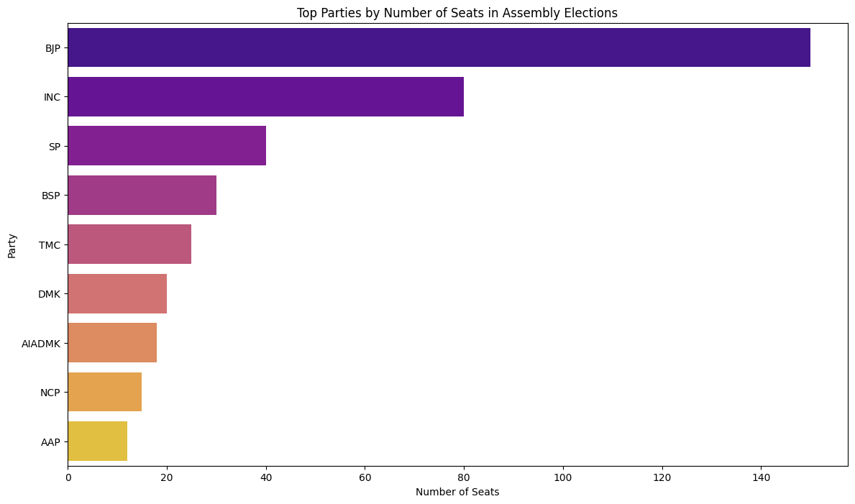

Conclusion

The Assembly elections demonstrated BJP's stronghold, significant presence of INC, and regional parties' influence.

Assembly Constituency Bye-elections Report

Key Insights

1. BJP's Lead: BJP won 10 seats in the bye-elections.

2. INC's Performance: INC secured 8 seats, showing competitive strength.

3. Regional Parties' Impact: SP, BSP, and TMC continued their influence in specific regions.

4. AAP's Growth: AAP won 3 seats, indicating its expanding influence.

Visualizations

Top Parties by Number of Seats in Assembly Bye-elections

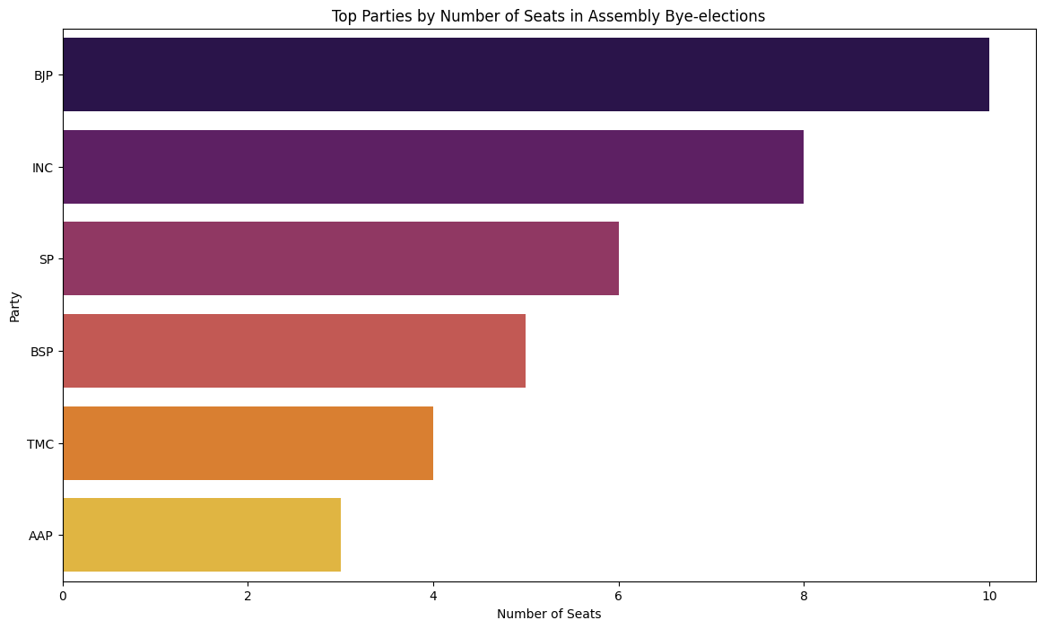

Conclusion

The bye-elections showcased BJP's lead, competitive presence of INC, and the ongoing influence of regional parties.